Simpsons 2
Downtown
Generic Texture Format

Generic Textures are grouped into 4 classes, Commercial, Old, Wrongside and Towers. Each texture class consists of 4 colours/ materials sets. For each material set there should be a min. 4 textures including a base material, door, shop window and window texture. Additional textures may include a trim texture and column texture where necessary.

The format for the generic textures is a rough outline towards organizing the texture for maximum reuse and simple tiling and texturing. All areas of the texture do not need to be filled in every texture (ie trim and sill), but should accommodate the use of trim and sills from other textures (so, avoid windows and patterns crossing between the “sill” and base material area). Where possible do not add the trim and sill textures to the entire texture set but accommodate their addition through added poly’s. Trim can be mixed and matched between Classes of textures (as they will be loaded) and sill textures may include other texture set’s base material, foundation texture etc…

Optimize and reuse wherever possible when texturing and avoid duplication, think unit/ component wise when creating the bitmaps. It’s better to have an additional 1-2 poly’s vs an entire new texture. However adding 16-30 added polys per face and then having 100 occurrences of that face may be excessive. Ask Yayoi to give the final decision.

Texture”A” – base material

The base material should include the “A” suffix, with naming conventions following the general texture document (HERE). Trim and Sill areas are optional if the texture requires it but should generally accommodate the use in other textures. Avoid textures crossing texture zones (ie a brick that spans the sill and base material area should be avoided. Brick however may be in the Sill and the Base areas.

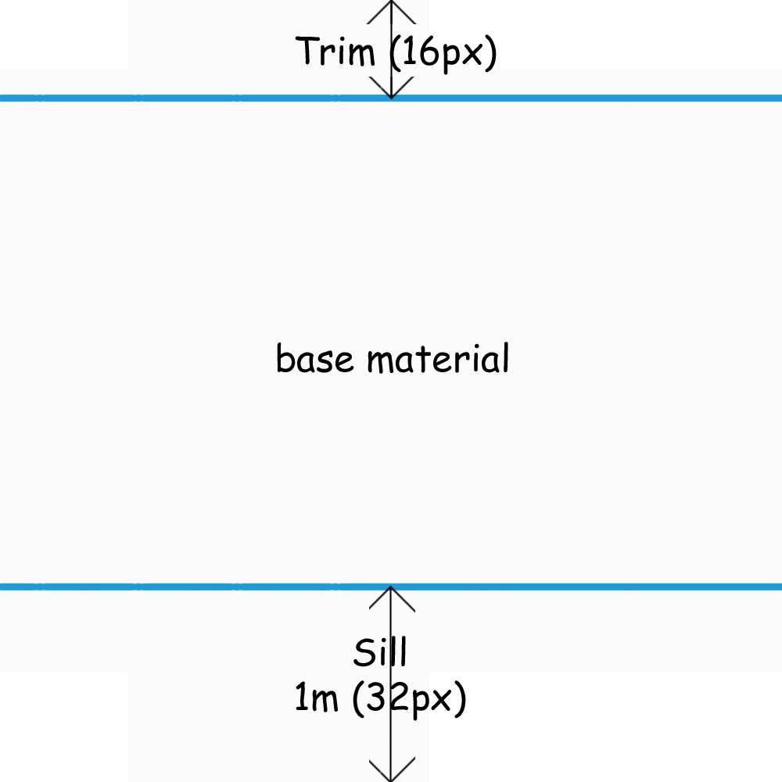  Texture “A” | 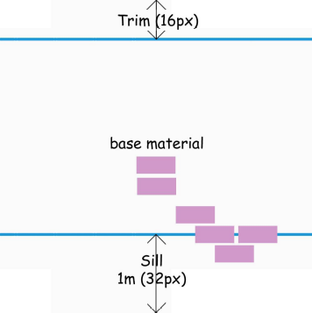  BAD placement of brick texture  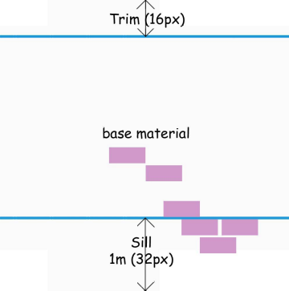  Good placement of brick texture

Texture “B” – Door

Door texture should be divided into two equal halves with the right side having the door and the left side having a side window, frame, moulding etc… The left half may be occupied with a single side window, multiple windows, moulding etc… Single side windows could be used as an additional material for mapping upper windows.

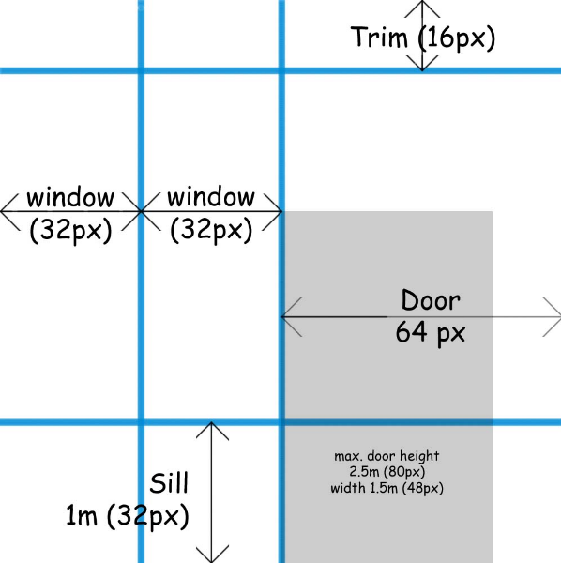  Texture “B” Format | 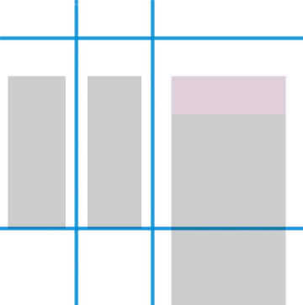  Door with double side window (centred) and transom window.

Texture “C” – Shop Window

Shop front windows are the “special case windows for the texture set and may include picture window, large windows, trim, moulding, wood panels, garage doors etc… Shop front window will receive a sign decal to make more unique.

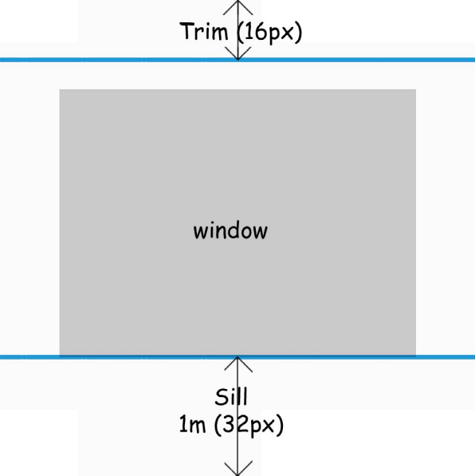  Texture “C” Format | 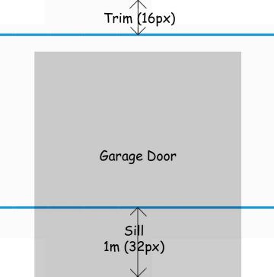  Shop front texture with Garage Door

Texture “D” – Window

Window textures are generally for the upper floor windows but could be used on the lower floors. Two window types in the window texture will allow for more variety and greater patterns. Window textures with 2 different window types should allow for ½ of the texture to be used (see base material mapping)

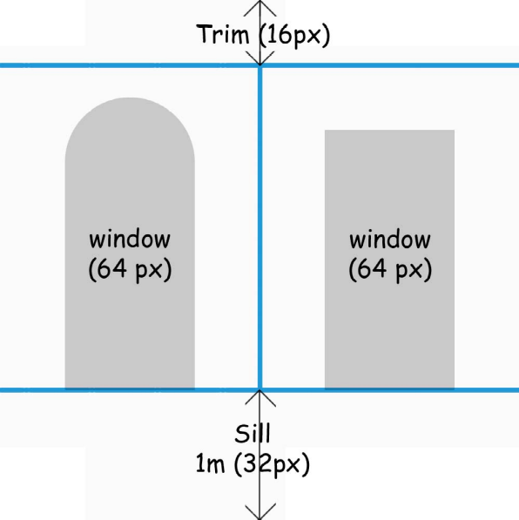  Texture “C” Format | 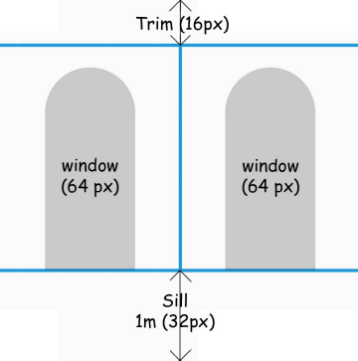  Only ½ texture is used here, therefore  Base texture needs to allow for only ½ texture tiling

Texture “E” – Column  Some textures will require a column detail. Use 1 smaller texture (128x32) with capital, shaft and base, mapping only the portion required.  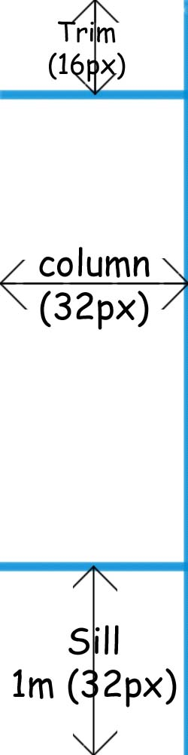 | Texture “F” – Trim  The trim texture should proportionately tile across the “Trim” area of all textures 4 times. Trim should be used at changes in materials, cornice lines etc…  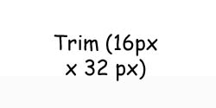

Material Classes

Commercial
In Vancouver, the Broadway corridor is typical “commercial” textures. Commercial textures are usually Art deco in style but lean towards a modernist look (less detail and cheap). This is the average texture class of the “regular” Simpsons commercial buildings (Town square, Police Station, Museum and Hospital)

“Old” Textures
Old texture classes should be similar to gastown. They feature a higher degree of brickwork, detail, heavier in appearance, columns, cornices etc… The old texture is the second most frequent Simpsons Texture and is found in the Hospital, Museum, Moes and Police areas.

“Wrongside” textures

Similar to both the Commercial and Old textures the Wrongside textures are generally dirtier and more run down, muddied colours dingy and grey.

(<-Palette)

Towers
Tower Textures are all clean shiny downtown textures with lots of glass, steel and concrete.

